Lambda:

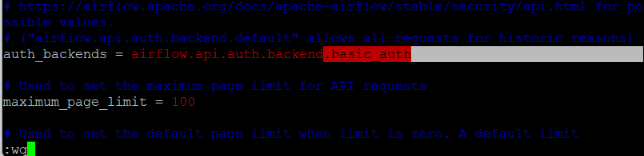

Lambda Function:

import json

import boto3

import os

import requests

airflow_dns="http://ec2-54-179-159-110.ap-southeast-1.compute.amazonaws.com:8080/api/v1/dags/Dummy_DAG/dagRuns"

username="admin"

password="admin"

def lambda_handler(event,context):

data={"conf":

{"spark_config_path":"",

"dataset_path":"",

"app_config_path":""}

}

header={"content-type":"application/json"}

response=requests.post(airflow_dns, data=json.dumps(data),headers=header,auth=(username,password))

print(f"Response:{response}")